Question 4: (2 marks)
The given file Q4.cpp already contains the function named triangleAltitude with 3 parameters a, b, c but its body is empty. You should complete this function to perform the following task:
Check if a, b and c are sides of a triangle then calculate and return the altitude from the side a, by the formula below:
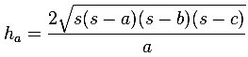
where s = 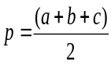
Otherwise return 0.

Notes:
- You can create new function(s) if you see it is necessary.
- Do not edit the main function.

Sample output:
